Lab 1:

Group Name: Open Source Security (OSS)

Group members: Ethan Barrett, Daniel Charles, Jason Hoare, Thomas Stinton

Project: Security System

Potential Ideas:

-Ultrasonic for opening doors/safes (door protection)

-Microphone

-Keypad to enable/disable OSS

-Window pressure sensor

-Speaker for siren

-IMU for important object motion

-User interface for status (WIFI connection)

-Keypad and LCD for armed/disarmed

-Personalised through website

-Light Sensors

-IR remote removed due to potential security issues

-Pressure and LDR not present in kit

3 Nodes, Central control, Safe and “Jewellery box”, ping = notification and logged, alarmed = siren

4th node may be introduced as website for user

Central Control: Use - To monitor whole system and allow human input for arming/disarming

Components – ESP, LCD Keypad, Speaker, Motion

-Keypad and LCD allow Arming/Disarming

-Motion sensor with timestamp (ping)

-Speaker for siren

Safe: Use - To provide feedback on internal safe environment

Components - RPi, Ultra-Sonic, Sound trigger, IMU(?)

-Ultra-Sonic aimed at safe door (detects opening, alarmed)

-Sound trigger monitors unusual noise (ping)

-IMU detects entire safe moving (alarmed)

“Jewellery box”: Use – To be hidden in a valuables box

Components: Nano, Wifi, IMU

IMU – detects entire box moving (alarmed)

Distributed System Diagram:

Node 1: Central, Node 2: Safe, Node 3: “Jewellery box”, Node 4: Website, Node 5: Extra (depends on device availability

Is wired Is wireless

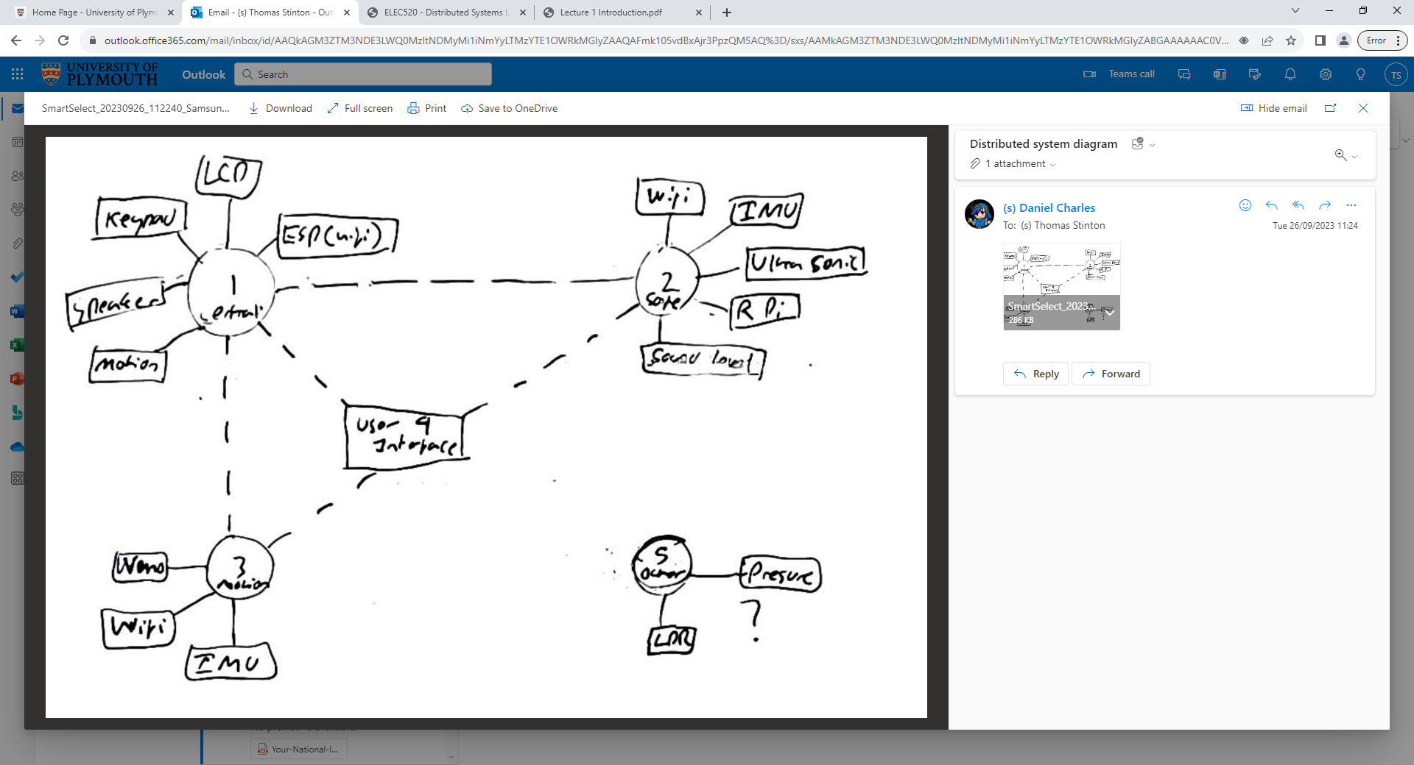

GitHub project has been made with all members included